%reset  
%matplotlib inline  
import matplotlib.pyplot as plt  
  
#IPython is what you are using now to run the notebook  
import IPython  
print ("IPython version: %6.6s (need at least 6.1.0)" % IPython.__version__)  
  
# Numpy is a library for working with Arrays  
import numpy as np  
print ("Numpy version: %6.6s (need at least 1.13.1)" % np.__version__)  
  
# SciKit Learn implements several Machine Learning algorithms  
import sklearn  
print ("Scikit-Learn version: %6.6s (need at least 0.19.0)" % sklearn.__version__)

Once deleted, variables cannot be recovered. Proceed (y/[n])? y  
  
  
IPython version: 7.8.0 (need at least 6.1.0)  
Numpy version: 1.17.2 (need at least 1.13.1)  
Scikit-Learn version: 0.22.1 (need at least 0.19.0)

# Set font sizes  
SMALL_SIZE = 10  
MEDIUM_SIZE = 12  
BIGGER_SIZE = 14  
plt.rc('font', size=SMALL_SIZE) # controls default text sizes  
plt.rc('axes', titlesize=SMALL_SIZE) # fontsize of the axes title  
plt.rc('axes', labelsize=MEDIUM_SIZE) # fontsize of the x and y labels  
plt.rc('xtick', labelsize=SMALL_SIZE) # fontsize of the tick labels  
plt.rc('ytick', labelsize=SMALL_SIZE) # fontsize of the tick labels  
plt.rc('legend', fontsize=SMALL_SIZE) # legend fontsize  
plt.rc('figure', titlesize=BIGGER_SIZE) # fontsize of the figure title

# import data  
gel_relaxed1 = np.loadtxt('./csv/gel_relaxed1.csv',delimiter=',',usecols=(0,1,3,4),skiprows=21)  
gel_relaxed2 = np.loadtxt('./csv/gel_relaxed2.csv',delimiter=',',usecols=(0,1,3,4),skiprows=21)  
gel_clenched1 = np.loadtxt('./csv/gel_clenched1.csv',delimiter=',',usecols=(0,1,3,4),skiprows=21)  
gel_clenched2 = np.loadtxt('./csv/gel_clenched2.csv',delimiter=',',usecols=(0,1,3,4),skiprows=21)  
silver_relaxed = np.loadtxt('./csv/silver_relaxed.csv',delimiter=',',usecols=(0,1,3,4),skiprows=21)  
silver_clenched_BAD = np.loadtxt('./csv/silver_clenched_BAD.csv',delimiter=',',usecols=(0,1,3,4),skiprows=21)  
silver_clenched_better = np.loadtxt('./csv/silver_clenched_better.csv',delimiter=',',usecols=(0,1,3,4),skiprows=21)

# Calculate SNR for gel  
SNR_gel1 = gel_clenched1[:,3] - gel_relaxed1[:,3]  
SNR_gel2 = gel_clenched2[:,3] - gel_relaxed2[:,3]  
  
# plot SNR data  
plt.figure(1)  
plt.title("SNR vs. Frequency for Gel Electrodes", fontsize=14)  
plt.xlabel("Frequency (Hz)")  
plt.ylabel("SNR (dB)")  
plt.plot(gel_clenched2[:2000,2],SNR_gel2[:2000], 'b-')  
plt.savefig('SNR_Gel.pdf')

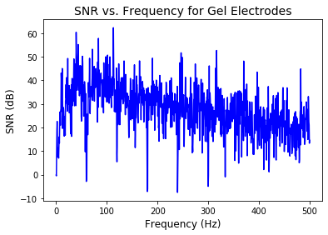

# Calculate the mean SNR from 0-500 Hz for gel  
  
gel_mean_500Hz_1 = np.mean(SNR_gel1[:2000])  
gel_mean_500Hz_2 = np.mean(SNR_gel2[:2000])  
gel_mean_500Hz = np.mean([gel_mean_500Hz_1, gel_mean_500Hz_2])  
  
gel_std_500Hz_1 = np.std(SNR_gel1[:2000])  
gel_std_500Hz_2 = np.std(SNR_gel2[:2000])  
gel_std_500Hz = np.mean([gel_std_500Hz_1, gel_std_500Hz_2])  
  
print('Mean SNR from 0-500 Hz for gel electrodes: ' + str(gel_mean_500Hz) + ' dB')  
print('Standard deviation of SNR from 0-500 Hz for gel electrodes: ' + str(gel_std_500Hz) + ' dB')

Mean SNR from 0-500 Hz for gel electrodes: 24.053194375 dB  
Standard deviation of SNR from 0-500 Hz for gel electrodes: 9.85431908596908 dB

# Calculate SNR for silver  
SNR_silver = silver_clenched_better[:,3] - silver_relaxed[:,3]  
  
# plot SNR data  
plt.figure(1)  
plt.title("SNR vs. Frequency for Silver Electrodes", fontsize=14)  
plt.xlabel("Frequency (Hz)")  
plt.ylabel("SNR (dB)")  
plt.plot(silver_relaxed[:2000,2],SNR_silver[:2000], 'm-')  
plt.savefig('SNR_Silver.pdf')

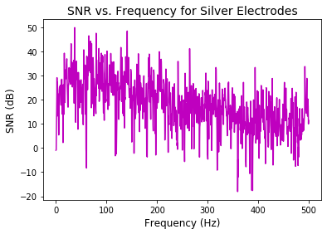

# Calculate the mean SNR from 0-500 Hz for silver  
  
silver_mean_500Hz = np.mean(SNR_silver[:2000])  
silver_std_500Hz = np.std(SNR_silver[:2000])  
  
print('Mean SNR from 0-500 Hz for silver electrodes: ' + str(silver_mean_500Hz) + ' dB')  
print('Standard deviation of SNR from 0-500 Hz for silver electrodes: ' + str(silver_std_500Hz) + ' dB')

Mean SNR from 0-500 Hz for silver electrodes: 17.87521615 dB  
Standard deviation of SNR from 0-500 Hz for silver electrodes: 9.952967824917057 dB